**Size and wealth bias in urban climate change mitigation research**

William F. Lamb, Felix Creutzig, Jan C. Minx

Abstract

Motivation paragraph

* 21st century emissions will come from urban areas
* Urban centred decisions will shape emissions: infrastructure choices, transportation planning, building design and use 1,2.
* Initiating a rapid urban transformation is not just a matter of technical interventions, but requires social, political change – particularly for demand-side energy reduction 3.

The need for case studies

* Case studies are useful for deepening empirical analysis (spatial data, qualitative methods like process tracing and interviews) and examining causal mechanisms through diverse methodologies.
* As in other fields of social inquiry, climate change mitigation studies tend to be dominated by top-down global, regional or international analysis ; or by
* Import

“…accounts of wealthier cities are often generalized as claims to universal knowledge about all cities” (Robinson 2011)

- mismatch of aggregate data

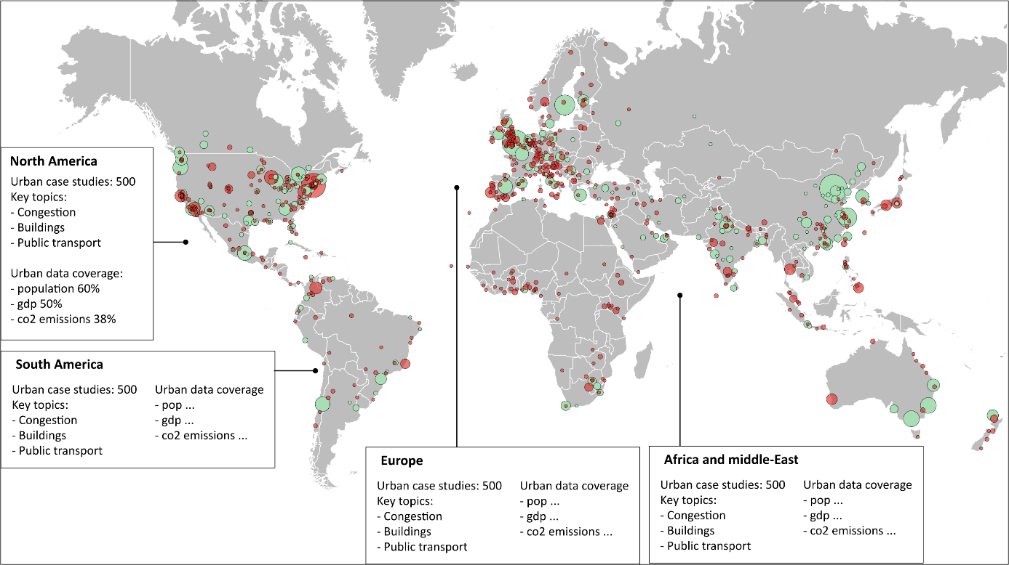

Scale matters in comparison. Comparison of whole functional cities makes sense for an analysis of “economic regions, wider city functioning, urban spatial forms, intra-metropolitan governance…” (Robinson 2011). But the whole city scale is less relevant for processes that exceed a city’s extent (metabolic flows), or operate at a smaller scale (individual development projects) (Robinson 2011).